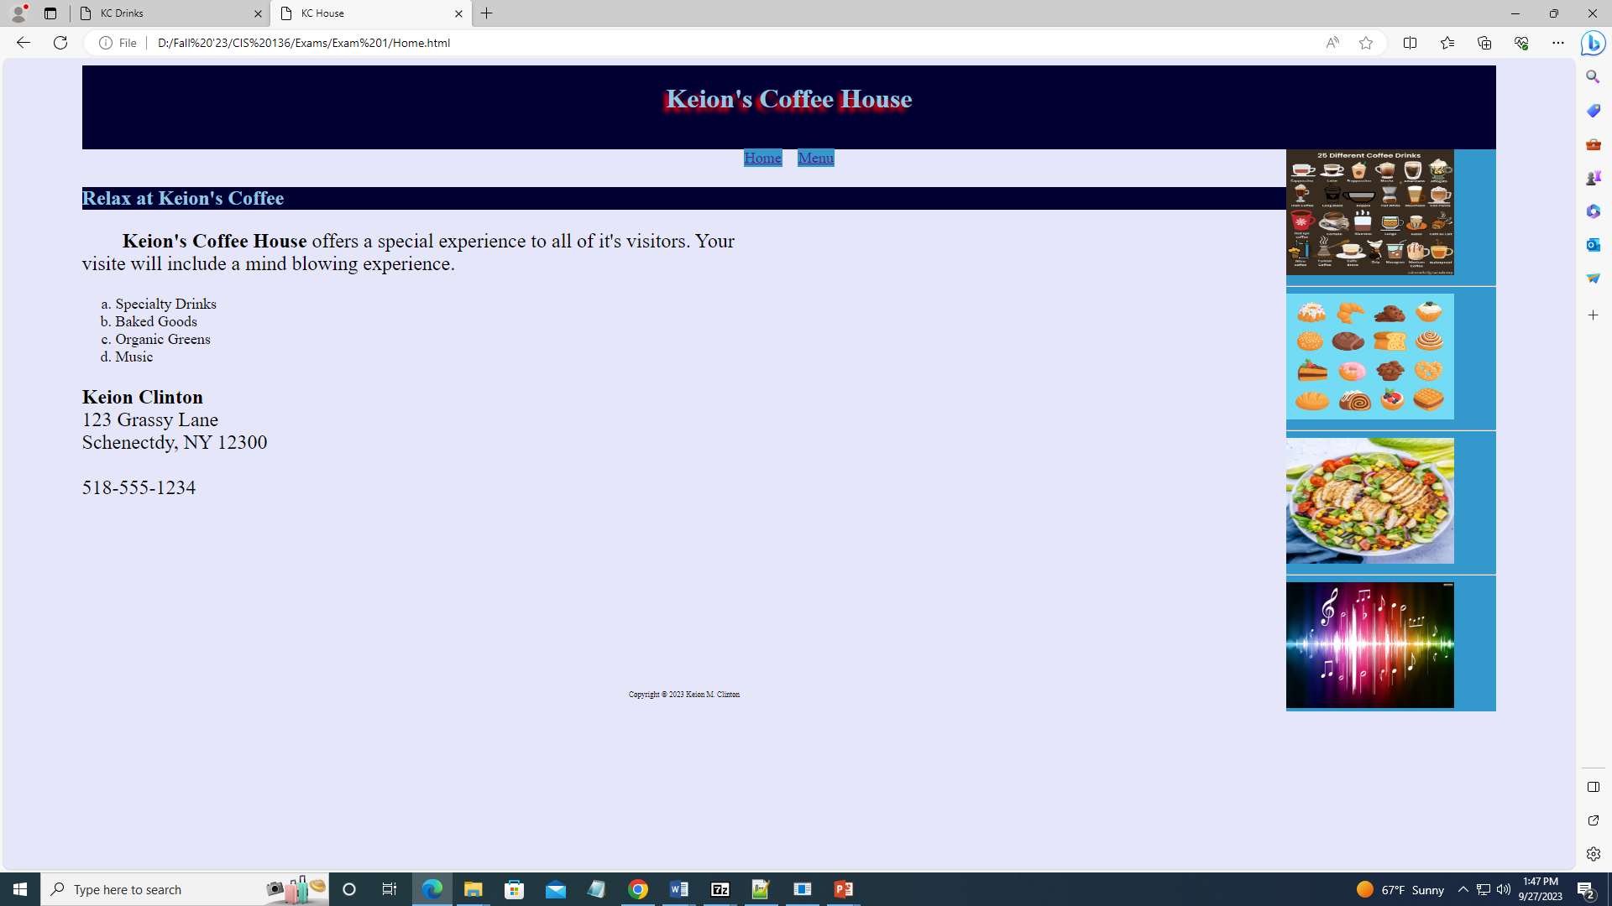

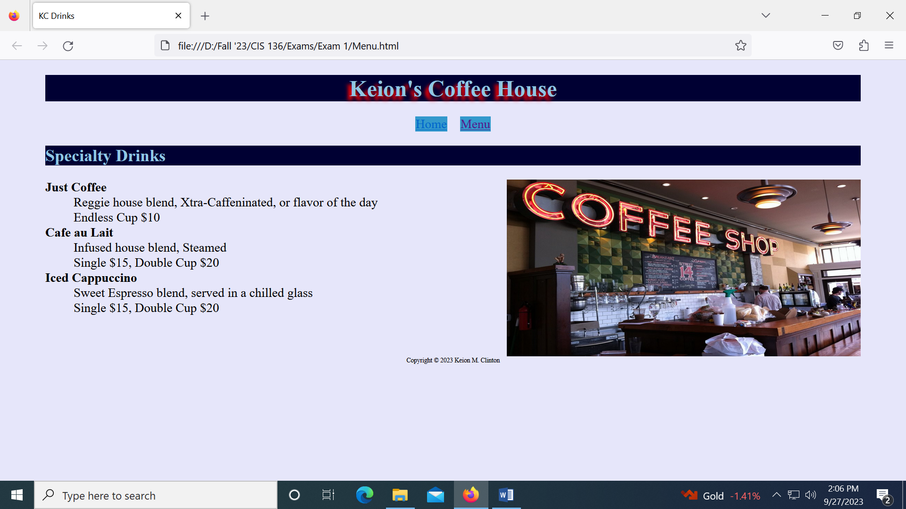

Color Palette: #e6e6fa, #3399cc, #000033, #90c7e3, & Red